SQL LAB 1

Lab 1. Create a Database & Table Using MySQL Command-Line Client.

* Create a database with the name StudentManagementSystem.

create database StudentManagementSystem;

use StudentManagementSystem;



* Create a table with named Student with attributes:
* StudentID (Primary Key)
* FirstName
* LastName

create table student(StudentID int primary key,

FirstName varchar(10),

LastName varchar(10)

);



* insert 5 records

INSERT INTO student (StudentID, FirstName, LastName) VALUES

(1, 'John', 'Doe'),

(2, 'Jane', 'Smith'),

(3, 'Mike', 'Brown'),

(4, 'Emma', 'Johnson'),

(5, 'Liam', 'Davis');

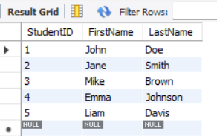

* then alter table with following fields:
* DateOfBirth
* Gender
* Email
* Phone

ALTER TABLE student

ADD DateOfBirth DATE,

ADD Gender VARCHAR(10),

ADD Email VARCHAR(50),

ADD Phone VARCHAR(15);

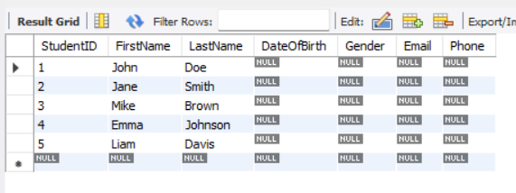

* update remaining value

UPDATE student

SET DateOfBirth = '2000-01-15', Gender = 'Male', Email = 'john.doe@example.com', Phone = '1234567890'

WHERE StudentID = 1;

UPDATE student

SET DateOfBirth = '2001-03-22', Gender = 'Female', Email = 'jane.smith@example.com', Phone = '9876543210'

WHERE StudentID = 2;

UPDATE student

SET DateOfBirth = '1999-07-08', Gender = 'Male', Email = 'mike.brown@example.com', Phone = '4567891230'

WHERE StudentID = 3;

UPDATE student

SET DateOfBirth = '2002-05-30', Gender = 'Female', Email = 'emma.johnson@example.com', Phone = '3216549870'

WHERE StudentID = 4;

UPDATE student

SET DateOfBirth = '2000-11-10', Gender = 'Male', Email = 'liam.davis@example.com', Phone = '7891234560'

WHERE StudentID = 5;

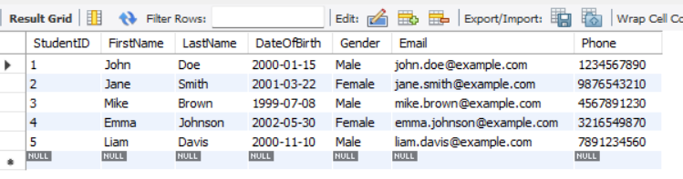

* Create a table with name Course with attributes:
* CourseID (Primary Key)
* CourseTitle
* Credits

CREATE TABLE Course (

CourseID INT PRIMARY KEY,

CourseTitle VARCHAR(50),

Credits INT

);



* Create a table with named Instructor with attributes:
* InstructorID (Primary Key)
* FirstName
* LastName
* Email

CREATE TABLE Instructor (

InstructorID INT PRIMARY KEY,

FirstName VARCHAR(20),

LastName VARCHAR(20),

Email VARCHAR(50)

);

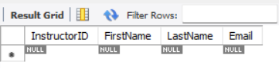

* Create a table with named Enrollment with attributes:
* EnrollmentID (Primary Key)
* EnrollmentDate
* StudentID(Foreign key)
* CourseID(Foreign Key)
* InstructorID(Foreign key)

CREATE TABLE Enrollment (

EnrollmentID INT PRIMARY KEY,

EnrollmentDate DATE,

StudentID INT,

CourseID INT,

InstructorID INT,

FOREIGN KEY (StudentID) REFERENCES Student(StudentID),

FOREIGN KEY (CourseID) REFERENCES Course(CourseID),

FOREIGN KEY (InstructorID) REFERENCES Instructor(InstructorID)

);

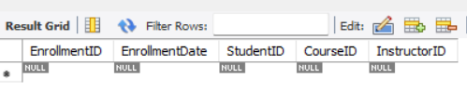

* Create a table with named Score with attributes:
* ScoreID (Primary Key)
* CourseID (Foreign key)
* StudentID (Foreign Key)
* DateOfExam
* CreditObtained

CREATE TABLE Score (

ScoreID INT PRIMARY KEY,

CourseID INT,

StudentID INT,

DateOfExam DATE,

CreditObtained INT,

FOREIGN KEY (CourseID) REFERENCES Course(CourseID),

FOREIGN KEY (StudentID) REFERENCES Student(StudentID)

);

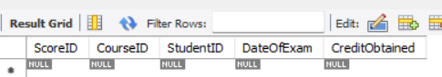

* Create a table with named Feedback with attributes:
* FeedbackID (Primary Key)
* StudentID (Foreign key)
* Date
* InstructorName

CREATE TABLE Feedback (

FeedbackID INT PRIMARY KEY,

StudentID INT,

FeedbackDate DATE,

InstructorName VARCHAR(50),

FOREIGN KEY (StudentID) REFERENCES Student(StudentID)

);

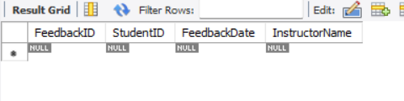

* Database and all table:

